How to Change Your 401K Election

- From the UKG Home Page under “New Hire Resources”, select “Vanguard 401K Plan Account Registration” to locate instructions (or go to my.vanguardplan.com)
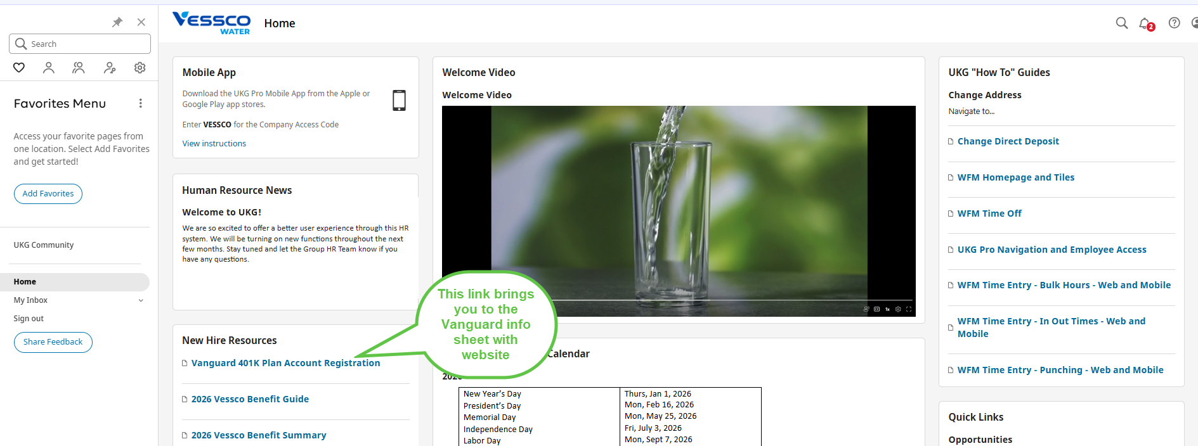

- Log into Vanguard website:
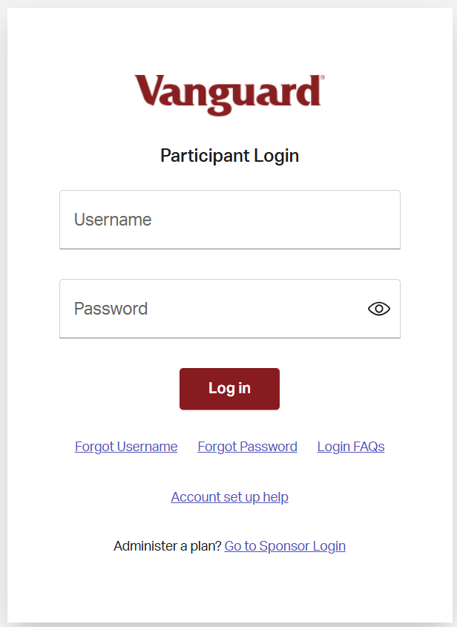

- Navigate to “Savings Rate” on the next page:
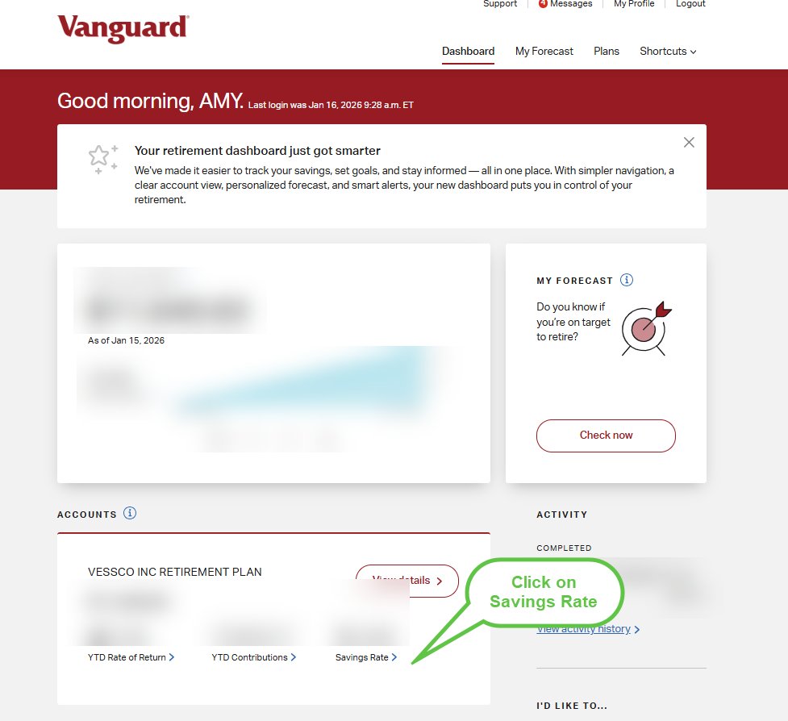

- Click “Change Contributions”:
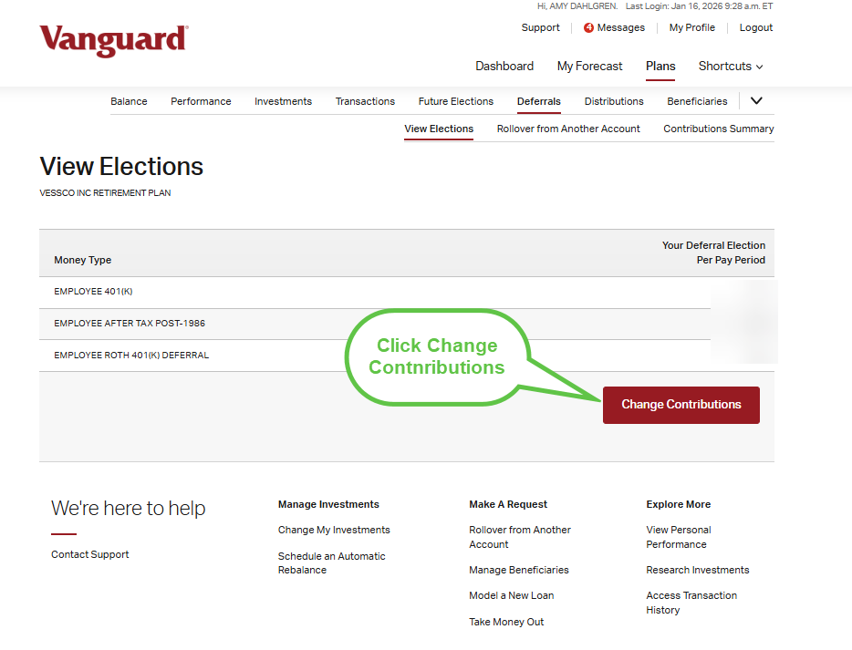

- Select which plans you want to change (this can be done one account at a time)
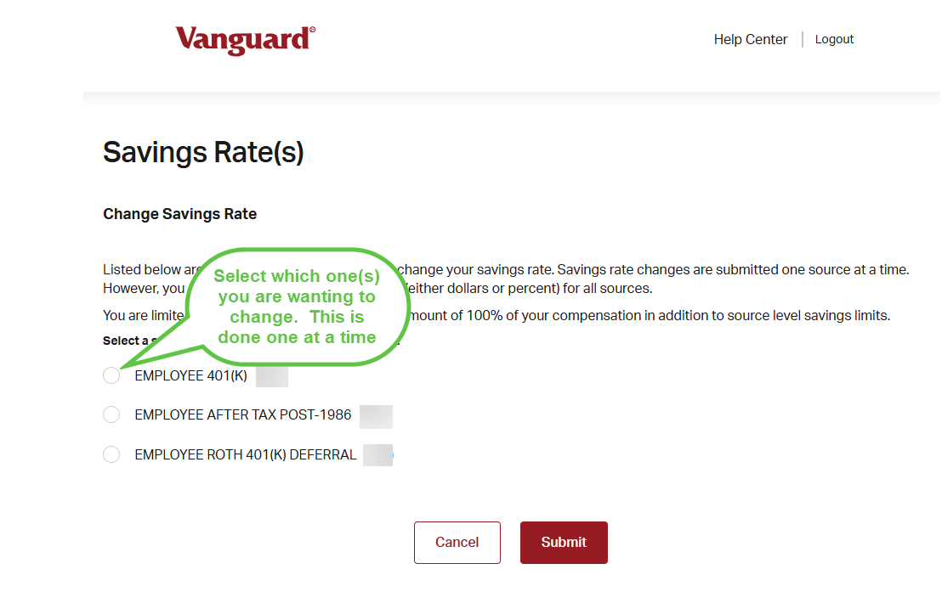

- After making the updates, click “Submit”
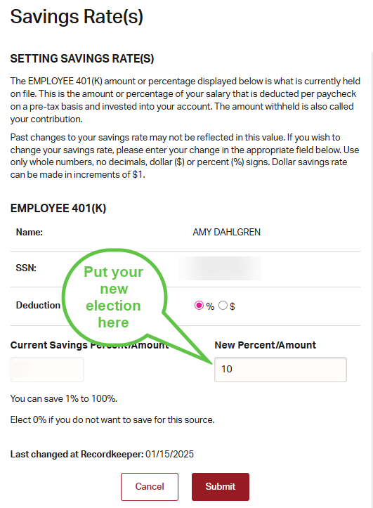

- Changes can take up to two payroll cycles to be updated on your paycheck.

